**Project 3**

**Ip addressof linux 1:-** 18.188.35.130

**Screenshot of linux 1:-** 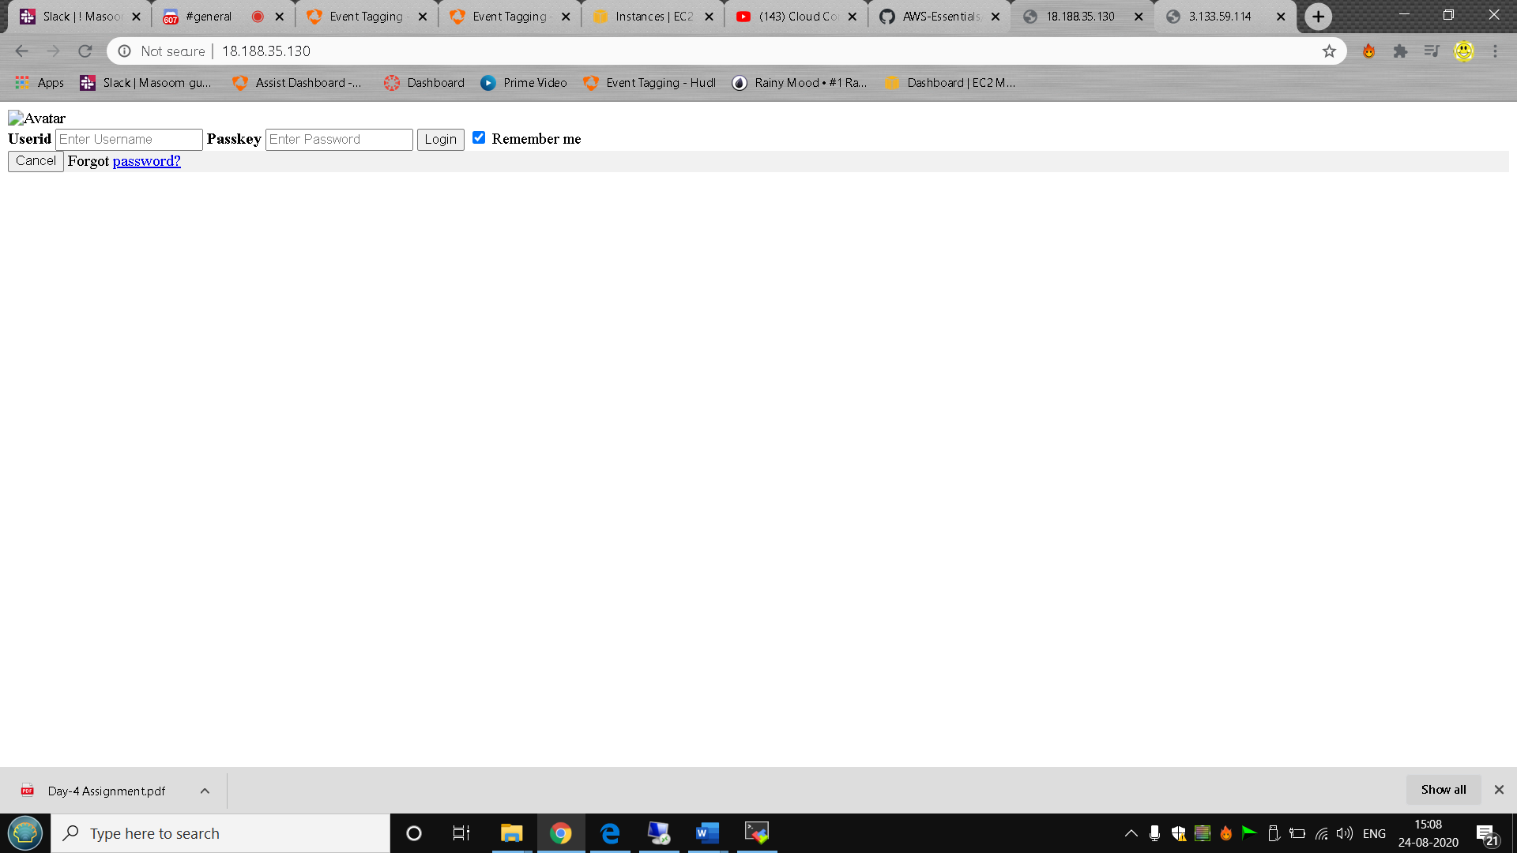

**Ip addressof linux 2:-** 3.133.59.114

**Screenshot of linux 2:-** 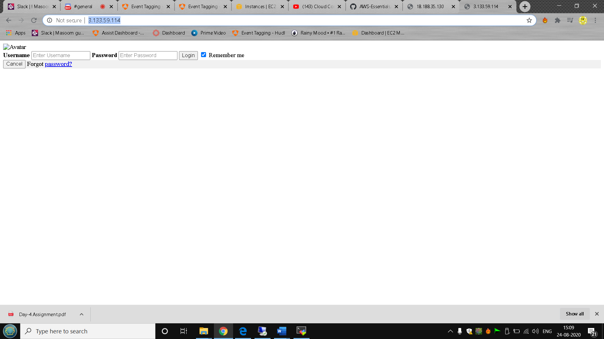

**Load balancer DNS :-** loadbalancer-391410350.us-east-2.elb.amazonaws.com

**Screenshot :-**

